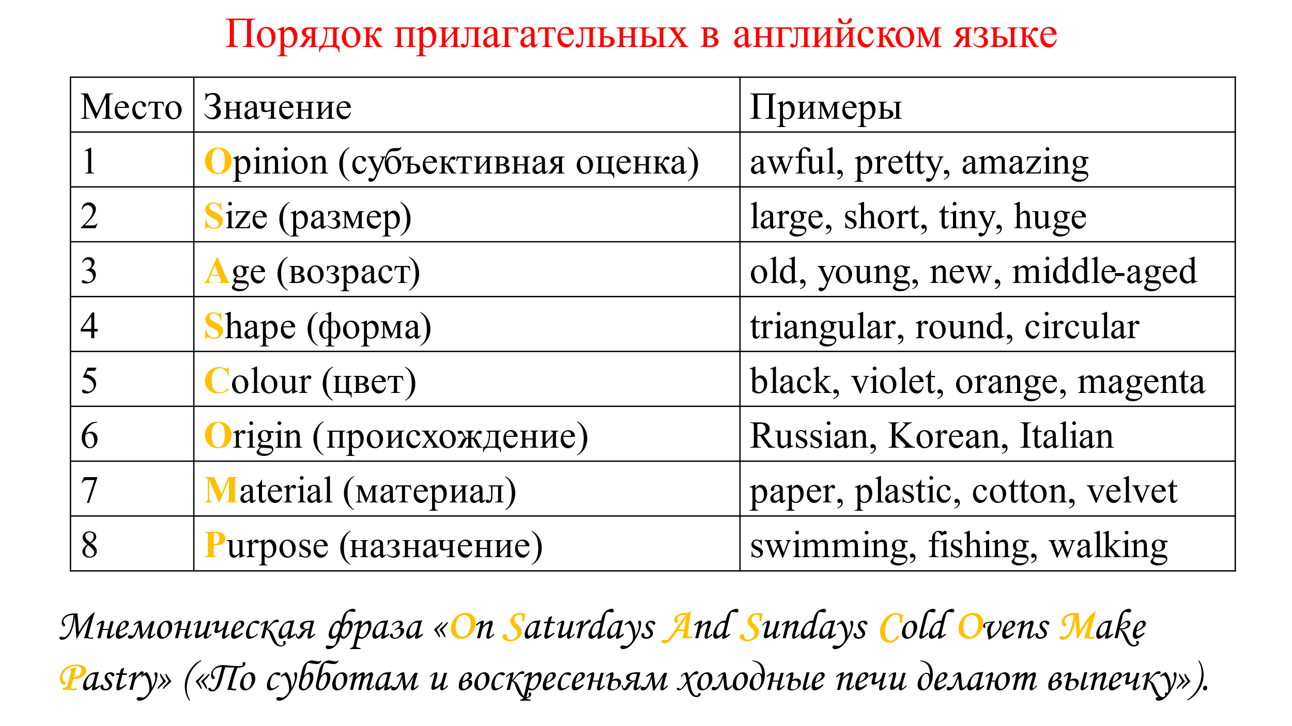

Упражнение 1. Распределите следующие прилагательные по группам в зависимости от значения:

Bad, zigzag, round, Floridian, youthful, big, teenage, red, black, concrete (бетонный), free, great, cotton, flat (плоский), antique, brown, international, large, oceanic, ceramic, dance, spherical (сферический), transparent (прозрачный), local, Irish, sleeping, military, political, French, recent (недавний), triangular, strong, white, young, glass, Spanish, wooden, ancient, walking, small, racing (гоночный), mature (зрелый), yellowish (желтоватый), Australian, blue, fabric (тканевый), straight (прямой), cooking (кулинарный), plastic, equatorial, leather (кожаный), old-fashioned, metal, tiny, steel, circular, square, huge, oval, pink, little, orange, northern, polar, American, work.

Упражнение 2. Put the following into the correct order:

1) suede (замшевые) / French / blue / soft / shoes

2) young / tall / Englishman

3) oval / Venetian / antique / valuable / glass

4) expensive / shiny / large / yellow / leather / case

5) oval / wooden / modern / nice / table

6) large / stone / beautiful / cottage

7) porcelain / tea / blue / thin / cup

8) tall / handsome / young / blonde / man

9) English / old / several / beautiful / castles

10) young / pretty / a lot of / French / girls

11) dark blue / best / silk / my / shirt

Упражнение 3. Put the adjectives in the correct order to describe the musical instruments

1) a / old / yellow / big / contrabass

2) a / new / yellow and brown / electric guitar

3) a / golden / big / saxophone

4) new / big / drums

5) a / old / big / black piano

Упражнение 4. Put the adjectives in the correct order

(red / long / cheap) dress

(wooden / new / huge) table

(beautiful / brick / new) house

(Japanese / green / fantastic) car

(Russian / silver / round) coin

(Nicе / blue / wooden) wall

(American / sentimental / long) song

(fair / curly / short) hair